4.37: a)
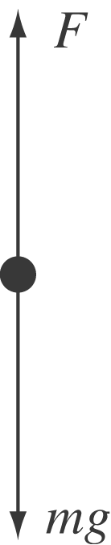
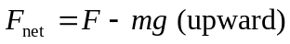

b) When the upward force has its maximum magnitude 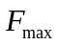 (the breaking strength), the net upward force will be 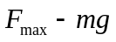 and the upward acceleration will be
